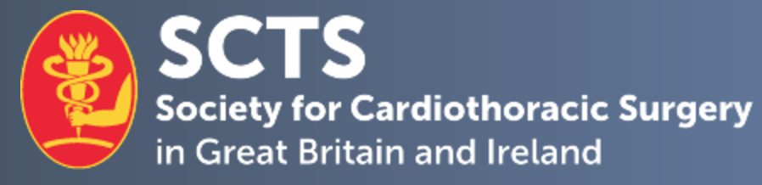

**SCTS Sustainability in Cardiothoracic Surgery Award Application Form**

|  |
| --- |
| **Application details** |

|  |  |  |  |
| --- | --- | --- | --- |
| Department Name |  | | |
| Hospital |  | | |
| Team Leader Name |  | | |
| Mobile number: |  | E-mail Address: |  |
| Current SCTS member | Yes No | | |

|  |
| --- |
| 1. **1. Describe the issue and how the sustainability initiative addresses it.** |
| No more than 400 words |
| 1. **2. Describe the process of implementing the sustainability initiative, including collaboration and the resources required.** |
| No more than 400 words |
| 1. **3. Describe the outcome of the sustainability initiative, including measures demonstrating the impact, in terms of outcomes, efficiencies, and cost.** |
| No more than 400 words |
| 1. **4. Any other information, including the transferability and dissemination of the project to the wider NHS.** |
| No more than 200 words |
| 1. **5. Names and job titles of others involved in the sustainability initiative.** |
| No more than 400 words |

**Declaration:** I hereby confirm that the details above are correct.

**Applicant’s signature:**

**Date:**

**Clinical Lead or Clinical Director’s signature:**

**Date:**

Please complete and return this form by email to emma@scts.org.

**Closing date for applications:** **29 November 2024**