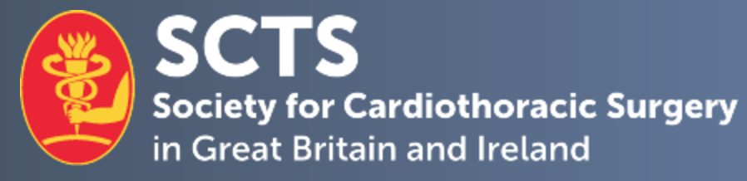

SCTS Nursing and Allied Health Professional sub-committee lead

Please confirm the position you are applying for: _______________________________

Personal details.
Candidate name
Current post & hospital
Mobile number: |  | E-mail address:
Current SCTS member

- 1. Describe your contributions to the specialty of cardiothoracic surgery and, in particular, to NAHPs.
No more than 300 words

- 2. Describe your contributions to the Society for Cardiothoracic Surgery (SCTS).
No more than 300 words

- 3. Describe the important challenges facing cardiothoracic NAHPs and how you would help to deal with these, if appointed.
No more than 300 words

- 4. Provide any further information to support your application.
No more than 300 words

Declaration:
I hereby confirm that the details above are correct.

Applicant signature:

Date:

Please complete and return this form, as well as a brief CV and letter of support from your manager/employer, by email to emma@scts.org.

Closing date for applications: 12th July 2024

