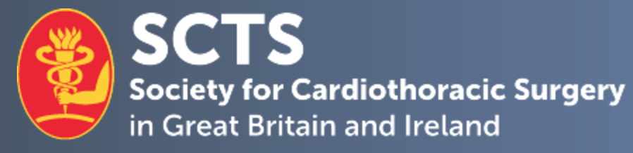

SCTS Education Secretary (cardiac) application form

Personal details.

Candidate name
Current post & hospital
Mobile number: |  | E-mail address:
Current SCTS member | Yes No

- 1. Describe your previous contributions to the specialty of cardiothoracic surgery and to the Society for Cardiothoracic Surgery (SCTS).
No more than 300 words

- 2. Describe your previous involvement with surgical education.
No more than 300 words

- If appointed, describe your proposed plans and vision for the post and the future of cardiothoracic surgical education.
No more than 300 words

- 4. Provide any further information to support your application.
No more than 300 words

Declaration:
I hereby confirm that the details above are correct and that, if selected as Cardiac Education Secretary, I shall attend Education sub-committee meetings and Executive Committee meetings on a regular basis. I will submit regular written reports to the Executive and Trustees when required.

I confirm that I will comply with the GMC’s Good Medical Practice guidance and the principles of the Codes of Conduct of the Royal Colleges of Surgeons of England and Edinburgh, in particular, treating colleagues with kindness, courtesy and respect and contributing to a positive working and training environment.

Applicant signature:

Date:

Please complete and return this form, as well as a brief CV, by email to nadia@scts.org.

Closing date for applications: Friday 27th November 2026

