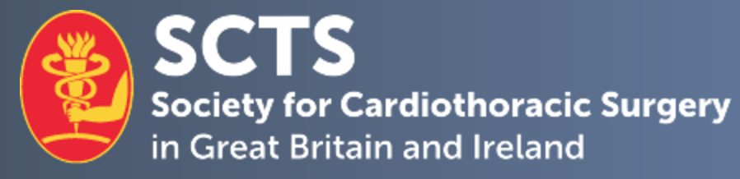

SCTS Equality, Diversity & Inclusion Appointed Member Application Form

Candidate Name
Current post & hospital
Mobile number: |  | E-mail Address:
Current SCTS member | Yes No

- 1. Describe your contributions to the specialty of cardiothoracic surgery.
No more than 300 words

- 2. Describe your contributions to the Society for Cardiothoracic Surgery (SCTS).
No more than 300 words

- 3. If appointed, describe the important issues that need to be dealt with and your proposed plans / vision for the sub-committee.
No more than 300 words

- 4. Provide any further information to support your application.
No more than 300 words

Declaration:
I hereby confirm that the details above are correct.

Applicant signature:

Date:

Proposing member signature:

Proposing member:

Please complete and return this form, as well as a brief CV, by email to sctsadmin@scts.org.

Closing Date for applications: 7th February 2022

