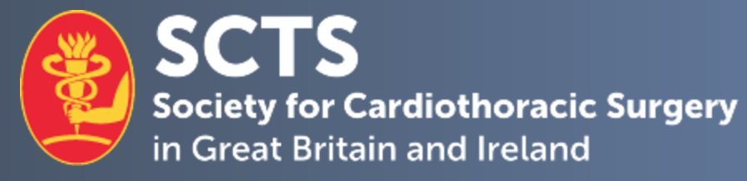

Student Education Co-Lead – Thoracic Surgery

Job description

The SCTS Student Education Thoracic Surgery Co-Lead will work alongside the existing Cardiac Surgery postholder to deliver and develop the portfolio of education recourses to promote and support the medical students.

The SCTS Student Education Thoracic Surgery Co-Lead will be a member of the SCTS Education Sub-committee, and accountable to the Education Secretaries and the Executive of the Society. The term of office is 3 years.

Mission
- To promote the career of Thoracic Surgery to medical, other university and 6th form students.
- This is to ensure that Thoracic Surgery which is not a large part of the undergraduate curriculum, is seen as an accessible merit-based career choice. This is important in view of the increased emphasis on ST1 and ST4 Thoracic Themed recruitment and training.
- To encourage entry to the speciality based on talent, ability, and teamwork as the overriding criteria, regardless of background.

Career Development
- Design and run the SCTS Student Day at the SCTS Annual Meeting. To allow maximum student attendance, this meeting will be held on the Sunday before the meeting.
- To oversee the Pat Magee student poster/presentation competition in the SCTS Annual Meeting.
- Oversee the site/team selection and oversee the annual Autumn Student engagement day.
- Promote other courses, which may be from other organisations relevant to Thoracic Surgery, particularly for example, the RSM and ASIT.

SCTS Fellowships
- To oversee, in conjunction with the SCTS Education Leads, the selection of Medical Student Fellowships.

SCTS Students Network
- To oversee the work of the SCTS Students Committee and medical school representatives in the promotion of Thoracic Surgery.
- For example, this can be in the promotion of audits or research.

Schools Engagement
- As a form of public engagement, to enable 6th formers, regardless of background to access information about Thoracic Surgery and to engage with Thoracic Surgeons.

