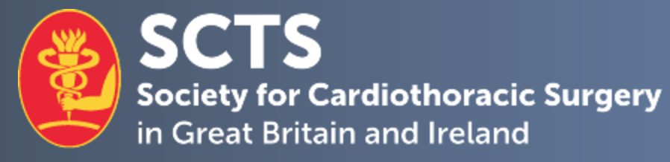

SCTS National Thoracic Surgical Tutor Application Form

Personal details.

Candidate Name
Current post & hospital
Mobile number: |  | E-mail Address:
Current SCTS member | Yes No

- 1. Describe your previous contributions to the specialty of cardiothoracic surgery and to the Society for Cardiothoracic Surgery (SCTS).
No more than 300 words

- 2. Describe your previous involvement with thoracic surgical education.
No more than 300 words

- If appointed, describe your proposed plans and vision for the post and the future of thoracic surgical education.
No more than 300 words

- 4. Provide any further information to support your application.
No more than 300 words

Declaration:
I hereby confirm that the details above are correct and, if selected as National Thoracic Surgical Tutor, to attend Education sub-committee meetings on a regular basis.

Applicant signature:

Date:

Please complete and return this form, as well as a brief CV, by email to isabelle@scts.org.

Closing Date for applications: 31st October 2021

