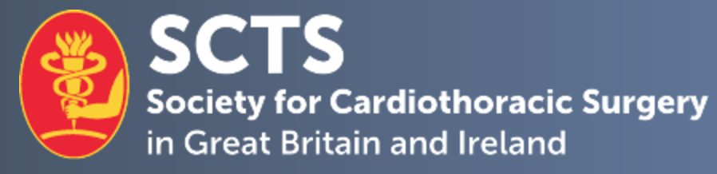

SCTS Medical Student Mentorship Programme

Mentor Application Form

Candidate Name
Current Post & Hospital
Mobile Number: |  | E-mail Address:
Current SCTS Member | Yes No

- 1. Describe your career progression and contributions to the specialty of cardiothoracic surgery.
No more than 500 words

- 2. Describe how you would be able to mentor medical students aspiring for a career in cardiothoracic surgery, and in particular, any areas of expertise that you could offer.
No more than 500 words

- 3. Provide any further information to support your application.
No more than 500 words

Declaration:
I hereby confirm that the details above are correct.

Applicant signature:

Date:

Please complete and return this form, as well as a brief CV, by email to isabelle@scts.org.

Closing Date for applications: 28th September 2022

