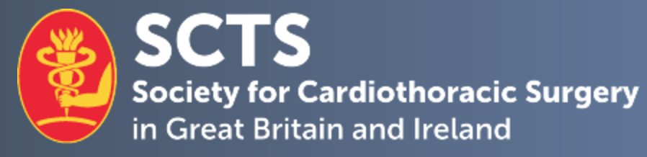

SCTS Medical Student Mentorship Programme

Mentee Application Form

Candidate Name
Current Medical School
Mobile Number: |  | E-mail Address:
Current SCTS Member | Yes No

- 1. Describe your progression and achievements at medical school and future aspirations in relation to cardiothoracic surgery.
No more than 500 words

- 2. Describe what you are looking for in a mentor and what you hope to gain from participating in the mentorship programme. In particular, are there any specific areas that you would like support, such as research, leadership or sub-specialty development?
No more than 500 words

- 3. Provide any further information to support your application.
No more than 500 words

Declaration:
I hereby confirm that the details above are correct.

Applicant signature:

Date:

Please complete and return this form, as well as a brief CV, by email to isabelle@scts.org.

Closing Date for applications: 28th September 2022

