SCTS Education Secretary

Job Description

The Education Secretary is responsible for delivering and developing the portfolio of education resources available for all members of the SCTS, including Consultants, nationally appointed surgeons in training,(NTNs), trust appointed doctors,(TAD), nurses, allied health professionals (AHP), as well as core surgical trainees and medical students interested in a career in cardiothoracic surgery. The Education secretary co-chairs the SCTS Education Sub-committee, and is accountable to the Executive of the Society. The term of office is 3 years and may be extended up to 5 years.

The principle duties include:
- Working with all the stream leads responsible for education of Consultants, NTNs,TADs,AHPs and medical students to deliver the current cardiothoracic surgical training course portfolio within the annual grant.
- Coordination of course delivery with course directors, faculty and education administrators, as well as liaising with industry as regards providing products, equipment and venue.
- Quality assurance of the current cardiothoracic surgical training course portfolio through feedback from the course directors, faculty and trainees.
- Oversee the pre- and post- course outcome assessment tools for trainees.
- Responsibility for new course development, as well as appraisal of the stream leads.
- Liaison with industry to procure funding for cardiothoracic surgical training courses.
- Working with Trust Appointed Doctors (TAD) Education leads with a view to developing TAD education portfolio mirroring that of NTN portfolio.
- Overseeing and promoting the SCTS Operative Video Prize and development of the SCTS Operative Video Library.
- Co-ordinate course delivery with partner organisations (EACTS, ESTS, ACCTAC, RCSEd).
- Support Meetings team with educational programme of SCTS University and AGM.
- Assessment of SCTS Fellowship applications.
- Implementation of course accreditation & approval process.
- Developing an education strategy with affiliated professionals.
- Active membership of the SCTS Executive committee, including attendance at meetings and conference calls.
- Liaising with the Communications team in showcasing SCTS Educational activities.
- Working with and supporting the SCTS education administrator to deliver the above.
- Working with the Medical student leads to support the medical student education programme to attract medical students and 6th formers into the specialty

Informal discussions may be held with Sri Rathinam (Communications and Education Secretary) or Carol Tan (Education Secretary), Narain Moorjani (Honorary Secretary) and Simon Kendall (President).
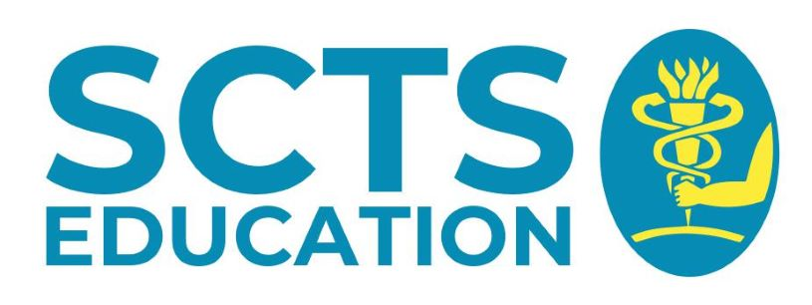
Interested members should submit a brief CV and a completed application form to isabelle@scts.org by 31st October 2021.

