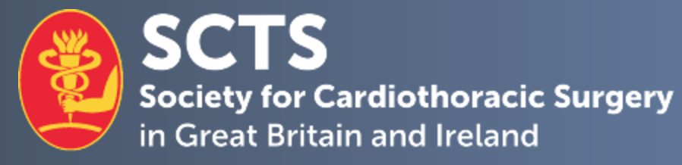

SCTS Representative to the Council of the College of Clinical Perfusion Scientists of GB and Ireland

Job Description
This post is to represent the interests of the SCTS at the Council meetings of the College of Clinical Perfusion Scientists of GB and Ireland. The Council meets five times in a calendar year (either virtually or at the RCS England in London). The SCTS Representative is also expected to attend the yearly Annual General Meeting of the Clinical Perfusion Scientists of GB and Ireland (venue changes every year).
The members of the Council meetings of the College of Clinical Perfusion Scientists include SCTS representatives (x2), ACTA representatives (x2), Lay person (x1), Society of Clinical Perfusion Scientists of Great Britain and Ireland (SCPS) representative (x1), practising Perfusionists and College of Clinical Perfusion Scientists Administrator.
Following the Council meetings of the College of Clinical Perfusion Scientists, the SCTS representative is expected to feedback to the SCTS Executive meetings regarding any pertinent issues that needs further discussion.

Ideal Candidate
- Member of SCTS
- Practising cardiac surgeon for at least 5 years
- Interest in perfusion issues
- Availability to attend most meetings

The term of office is 3 years.
If you are interested in the post, please complete the enclosed application form and send a brief CV to Isabelle Ferner (isabelle@scts.org). Further information can be obtained from the current representatives (Phil Botha or Chris Efthymiou) by email (isabelle@scts.org).
The closing date for applications is midday on Wednesday 6th April 2022, with interviews provisionally planned for the Monday 25th April 2022 after 18.30.

