SCTS National Thoracic Surgical Tutor

Job Description

The National Thoracic Surgical Tutor is responsible for delivering and developing the portfolio of education resources produced for nationally-appointed cardiothoracic surgical trainees. The Tutors are members of the SCTS Education Sub-committee, and accountable to the Education Secretary and the Executive of the Society. The term of office is 3 years and may be extended up to 5 years.

The principal duties include:
- Working with the SCTS National Cardiac Surgical Tutor to deliver the current cardiothoracic surgical training course portfolio within the annual grant.
- Coordination of course delivery with course directors, faculty and education administrators, as well as liaising with industry as regards providing products, equipment and venue.
- Quality assurance of the current cardiothoracic surgical training course portfolio through feedback from the course directors, faculty and trainees.
- Developing pre- and post- course outcome assessment tools for trainees.
- Responsibility for new course development, as well as identifying new course directors and faculty members with evolution of the courses.
- Liaison with industry to provide funding for cardiothoracic surgical training courses
- Keeping track of progress of NTNs and updating NTN trainee lists
- Working with Trust Appointed Doctors (TAD) education leads with view to developing a TAD education portfolio mirroring that of NTN portfolio
- Co-ordinating and promoting the SCTS Operative Video Prize and development of the SCTS Operative Video Library.
- Co-ordinate course delivery with partner organisations (EACTS, ESTS, ACCTAC, RCSEd).
- Support Meetings team with educational programme of SCTS University and AGM.
- Assessment of SCTS NTN Fellowship applications.
- Implementation of course accreditation & approval process.
- Developing an education strategy with affiliated professionals.
- Active membership of the SCTS Education sub-committee, including attendance at meetings and conference calls.
- Attendance at SCTS Thoracic Surgery Sub-committee meetings and conference calls
- Working with and supporting the SCTS education administrator to deliver the above

Informal discussions may be held with Sri Rathinam (Communications and Education Secretary) or Carol Tan (Education Secretary).
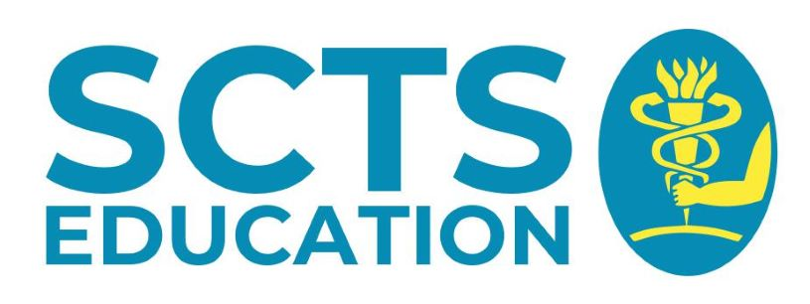
Interested members should submit a brief CV and a completed application form to isabelle@scts.org by 31st October 2021.

