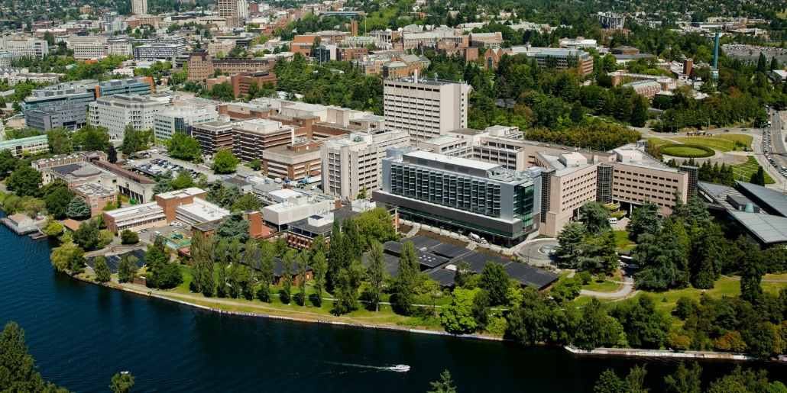

**University of Washington Medical Center – Montlake**

1959 NE Pacific Street

Seattle, WA 98195

––––––

Kathleen Berfield, MD

Interim Program Director

––––––

**Cardiothoracic transplant & MCS Faculty List**

Michael Mulligan, MD

Jeffrey Keenan, MD

Maziar Khorsandi, MD

Aaron Cheng, MD

Kathleen Berfield, MD

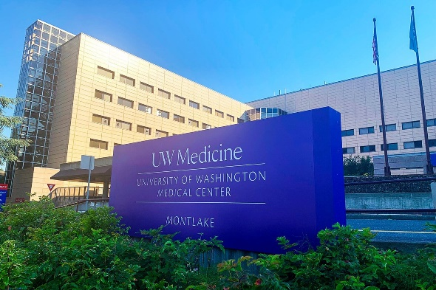

**Cardiothoracic Transplant and Mechanical Circulatory Support Fellowship**

**University of Washington Medical Center, Seattle, Washington, USA**

is searching for well-qualified candidates to fill one (1) fellowship position.

Applicants must be board-eligible or certified with the American Board of Thoracic Surgery (ABTS) OR the **foreign equivalent** in Thoracic Surgery and be eligible for licensure in Washington State.

The primary objective of the MCS and Cardiothoracic Transplant Fellowship is to produce a balanced, well-qualified thoracic transplant surgeon prepared for practice in an academic or private practice environment. Over the course of this 12-month program, the fellow will gain comprehensive experience in the management of end-stage heart and lung disease. The fellow will become a skilled surgeon in the following aspects:

* Cardiac transplant and mechanical circulatory support
* Lung transplant
* Procurement/donor management
* Complex structural heart and coronary surgery

At the end of the year of training, fellows will   
meet the requirements to obtain UNOS and   
JCHO certifications.

**Qualified candidates should send their CV, a letter of intent, and three current letters of recommendation to** [**ctrespa@uw.edu**](mailto:ctrespa@uw.edu)**.**

**For more information, see** [**https://uwsurgery.org/introduction-to-surgical-education3/cardiothoracic-transplant-mcs/**](https://uwsurgery.org/introduction-to-surgical-education3/cardiothoracic-transplant-mcs/)