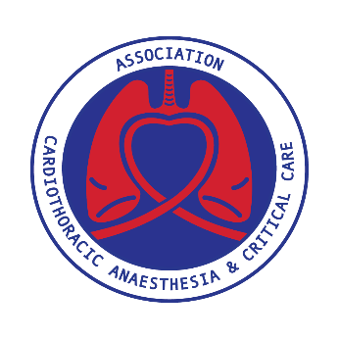
ACTACC & SCTS Joint Study Day
Royal Society of Medicine, London
Monday 6th November 2023

THORACIC PROGRAMME
GUY WHITTLE AUDITORIUM

08:00 – 09:00 Registration Opens, Refreshments & Trade Exhibition

09.00 – 10.30 SESSION 1 | CHANGING LANDSCAPE TO CANCER TREATMENT
Chaired by Mark Steven and Ralitsa Baranowski

09:00 – 09:20 Frailty in Thoracic surgical patients
Jugdeep Dhesi
09:20 - 09:40 Neoadjuvant chemotherapy; an oncology perspective for lung cancer management
Samreen Ahmed
09:40 – 10:00 Surgical implications of neoadjuvant chemotherapy
Tim Batchelor
10:00 – 10:20 Outcomes/ GIRFT update
Doug West
10:20 – 10:30 Questions

10.30 – 11.00 Refreshments, Trade Exhibition & Networking with SCTS Attendees
Posters will be on display in the Max Rayne Foyer

11.00 – 12.30 SESSION 2 | THORACIC SERVICE DEVELOPMENT
Chaired by Sajith Kumar and Aman Coonar

11:00 – 11:30 Starting, maintaining and growing a Thoracic Robotic Programme: The Glasgow Experience
Jennifer Whiteley
11:30 – 12:00 Workforce; Training, recruitment and retention
Simon Gardner
Mark Jones
12:00 – 12:20 The Dream team debate
‘This house believes it is optimal to deliver thoracic care in a stand-alone thoracic unit rather than a combined cardiothoracic unit’
For; Matt Molyneux Jakub Kadlec
Against; Jonathan Kendall David Healy
12:20 – 12:30 Questions

12.30 – 13.30 Lunch, Trade Exhibition & Networking with SCTS Attendee
Posters will be on display in the Max Rayne Foyer

13.30 – 15.00 SESSION 3 | PERI-OPERATIVE BONDING
Chaired by Jonathan Kendall and Mathew Thomas

13:30 – 14:00 Shared management of complex airways
Maninder Kalkat and Sajith Kumar
14:00 – 14:30 LVRS; 1 year on from commissioning
Sri Rathinam and Sameer HannaJumma
14:30 – 15:00 RATS 10 Tips for performing lobectomy
Sasha Stamenkovic and Selina Ho

15.00 – 15.30 Refreshments, Trade Exhibition & Networking with SCTS Attendees
Posters will be on display in the Max Rayne Foyer

15.30 – 17.00 SESSION 4 | PAIN MANAGEMENT
Chaired by Matthew Molyneux and Jennifer Whiteley

15:30 – 16:00 Surgical Stabilisation of Rib Fractures for non-flail chest; Yes or No?
John Edwards
16:00 – 16:20 Regional analgesia; current evidence and update
Cheng Ong
16:20 – 16:40 Cryotherapy; one centres experience
Benjamin Waterhouse
16:40- 17:00 Questions

Close Meeting

