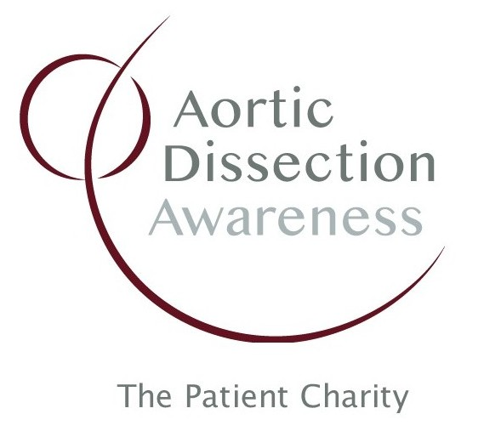
MEDIA RELEASE

23rd July 2023

Contact: Sarah Nuttman
E-mail: sapn89@hotmail.com
Tel: +44 (0) 7429 397311

Royal Papworth Hospital prepares for a full house for Aortic Dissection Awareness Day UK after programme and speakers announced

Organisers of the Aortic Dissection Awareness Day UK national conference on 19th September, hosted by Royal Papworth Hospital, say the event is now full, after the programme and speakers were announced in June. A mixed audience of patients, relatives, healthcare professionals and researchers will enjoy a day of talks and discussion about Aortic Dissection, organised by the national patient charity and sponsored by Terumo Aortic.
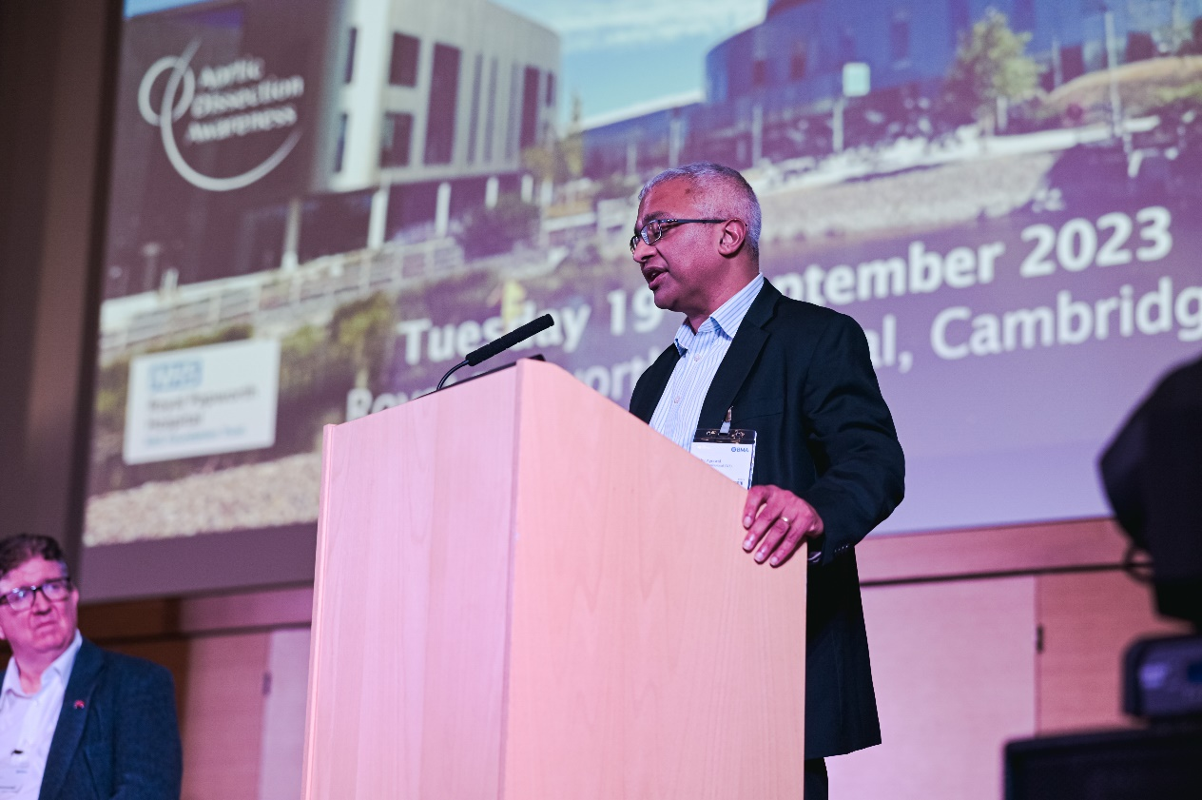

Aortic Dissection is a life-threatening condition involving a tear in the body’s biggest artery, the Aorta, which carries blood from the heart to the brain, limbs and vital organs. Aortic Dissection kills more people in the UK each year than road traffic accidents, but awareness of the disease, even in the medical profession, is low. In 2016, a small group of survivors and relatives took the initiative and created Aortic Dissection Awareness Day UK – a national event, now in its 8th year. Their small organisation grew to become the national patient charity, Aortic Dissection Awareness UK & Ireland, with over 1,000 members. Each year, the patient charity awards the hosting of its flagship national event, Aortic Dissection Awareness Day UK, to an organisation doing great work in the field. In recognition of its excellent Aortic service, Royal Papworth Hospitals NHS Foundation Trust has been awarded the honour of hosting Aortic Dissection Awareness Day UK 2023.

Dr. Bobby Agrawal, Consultant Cardiac and Thoracic Radiologist at Royal Papworth Hospital, said: “We’re delighted that Aortic Dissection Awareness UK & Ireland have recognised our expertise and excellence in Aortic surgery to the profession and to our patients and our role in sharing our knowledge to the sector. We look forward to welcoming them and all the delegates to Royal Papworth in September.”

Mr. Gareth Owens, Chair of the national patient charity, explained: “We created Aortic Dissection Awareness Day UK as a national focal point to raise awareness of this disease and shine a light on best practice, such as the care patients receive from the Royal Papworth Aortic service. Over the last 8 years, the event has grown into a popular and successful national conference, recognising the very best in UK Aortic Dissection patient care and research.”

Speakers at the event include a patient, Dr. Chris Stewart, who owes his life to the Aortic Dissection care provided at Royal Papworth. Many of the clinicians involved in delivering this care will present their work and how it contributes to a successful Aortic Dissection successful patient pathway. The Presidents of the two professional surgical societies involved in treating Aortic Dissection patients: Mr. Narain Moorjani of the Society for Cardiothoracic Surgery in Great Britain & Ireland and Miss Rachel Bell of the Vascular Society will talk about the role of their organisations in improving Aortic Dissection care across the UK.

The full event programme is available online here: https://tinyurl.com/ADADUK23

PHOTO: Dr. Bobby Agrawal is one of the hosts of Aortic Dissection Awareness Day UK 2023 at Royal Papworth Hospital

