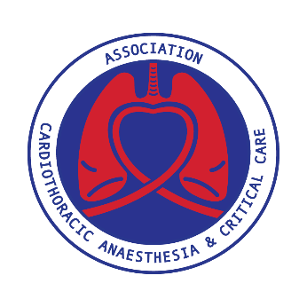
ACTACC & SCTS Joint Study Day
Royal Society of Medicine, London
Monday 6th November 2023

CARDIAC PROGRAMME
MAX RAYNE AUDITORIUM

08:00 – 09:00 Registration Opens, Refreshments & Trade Exhibition

09.00 – 10.30 SESSION 1 ERAS
Chaired by Seema Agarwal and Narain Moorjani

09:00 – 09:20 ERAS in cardiac surgery
Melissa Evans
09:20 – 09:40 Fast track cardiac surgery
Christopher Palin
09:40 – 10:00 Virtual ward
Bil Kirmani
10:00 – 10:20 Benchmarking in cardiac surgery – new adult cardiac surgery registry and quality assurance programme
Uday Trivedi
10:20 – 10:30 Questions

10.30 – 11.00 Refreshments, Trade Exhibition & Networking with ACTACC Attendees
Posters will be on display in the Max Rayne Foyer

11.00 – 12.30 SESSION 2 PROFESSIONAL BEHAVIOURS
Chaired by Niall O'Keeffe a and Indu Deglurkar

11:00 – 11:30 BHU - throughout medicine and health care. Results of ACTACC and SCTS surveys. ACTACC and SCTS Trainee Representatives
Abdul Badran and Rahul Mudannayake
11:30 – 11:50 Calling it out - How to support / protect victims and witnesses of BHU tackle BHU - a user guide?
Helen Garr
11:50 – 12:05 Pre-recorded: What makes a theatre safe and supportive?
Bhuvaneswari Krishnamoorthy
12:05 – 12:20 What makes an intensive care / HDU safe and supportive
Leah Hughes
12:20 – 12:30 Questions

12.30 – 13.30 Lunch, Trade Exhibition & Networking with ACTACC Attendees
Posters will be on display in the Max Rayne Foyer

13.30 – 15.00 SESSION 3 DEVELOPING PRACTICE
Chaired by Jacqueline Church and Betsy Evans

13:30 – 13:50 Minimally invasive cardiac surgery – roadblocks to wider adoption in the NHS
Ranjit Deshpande
13:50 – 14:10 New AHA guidelines for aortic diseases – is the UK ready to adopt it?
Manoj Kuduvalli
14:10 – 14:30 OPCAB vs ONCAB – the Anaesthetists’ perspective
Matt Bell
14:30 – 14:50 TAVI mission creep; is the steady spread into low risk cases evidence based?
Reuben Jeganathan

14:50 – 15:00 Questions

15.00 – 15.30 Refreshments, Trade Exhibition & Networking with ACTACC Attendees
Posters will be on display in the Max Rayne Foyer

15.30 – 17.00 SESSION 4 MDT DECISION MAKING
Chaired by Claire Boynton and Manoj Kuduvalli

15:30 – 15:50 Role of Anaesthetist and Intensivist in high risk MDT
Neil Brain
15:50 – 16:10 Vasoplegia, pharmaceutical intervention in theatre and ICU
Carlos Corredor Rosero
16:10 – 16:30 Mechanical support, access for all post cardiotomy
Antonios Kourliouros
16:30 – 16:50 Coagulopathy, point of care vs intuition
Seema Agarwal
16:50 – 17:00 Questions

Close Meeting

