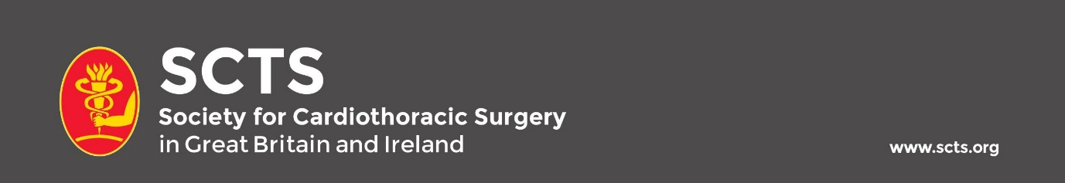

**SCTS Elected Trustee**

This is a position of responsibility with the opportunity to make a difference to your society and help shape the future of UK cardiothoracic surgery.

Elected trustees are elected by the membership to the SCTS Executive. There are usually two posts available each year. The term of office is for three years, but occasionally, trustees may be co-opted to serve an extended term on an annual basis.

Elected trustees are voting members of the Executive and help determine policy and shape the future of our society. They should, therefore, have the backing of membership to ensure they properly represent contemporary opinions.

Trustees are expected to attend 3-4 Executive meetings annually, usually at the RCS in London. According to experience, they will also be invited to join or co-chair one of the executive subcommittees. Much of the latter business will be conducted via email and telephone conferences.