Congenital Cardiac Surgery Committee
Anderw Parry
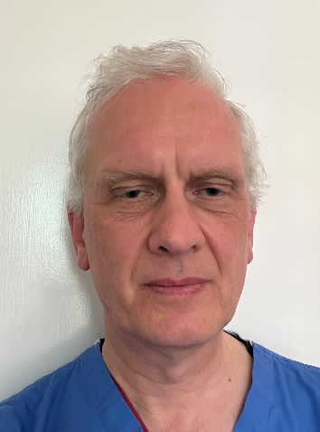
Co-chair Andrew Parry
Executive co-chair Aman Coonar
Audit Lead Serban Stoica
Deputy Audit Lead Phil Botha/Branko Mimic
Education Lead Shafi Mussa
Nursing & AHP Representative TBC
Trainee Representative Shubhra Sinha

Unit Members (unlike other subcommittees every unit has a representative)
Tim Jones/Natasha Khan (Birmingham)
Ramana Dhannapuneni (Liverpool)
Branko Mimic (London GOSH)
Giuseppe Pelella (Leeds)
Mark Danton/Ed Peng (Glasgow)
Conal Austin (Guy's & Evelina)
Mark Redmond (Dublin)
Shafi Mussa (Bristol)
Mohamed Nassar (Newcastle)
Nicola Viola (Southampton)

Surgical workforce
The surgical workforce in UK has been under considerable change over the last 10 years. A large number of consultant surgeons (52%) have left the profession in the UK for various reasons, and 39% of new appointees have been through UK training
There has therefore been a speciality-wide discussion why this has been occurring, and having gathered data and opinions from all units a ‘document’ has been written and endorsed by every unit that sets out what the surgeons believe a ‘Good Unit Looks Like’. This document is under consideration by the SCTS Executive currently, and it is hoped that it will be endorsed by the Society before being submitted to central NHS authorities. It is intended that the model can be used for local Trusts to support a working environment in which consultant surgeons are able to provide the quality of care that is expceted.
FRCS CTh examination
Currently the final assessment of a surgeon’s factual knowledge is an examination in Cardiothoracic surgery in its generality. For a candidate wishing to pursue a career in congenital cardiac surgery there is no formal examination in this specific sub-speciality which could lead to challenges. The subcommittee is working through the complex issues of validating an examination sat by a small number of candidates and will be providing a draft recommendation to the FRCS Examination board during the next year.

NICOR
Serban Stoica has takne over as SCTS audit lead. He has also taken on the role of lead for NICOR (congenital) nationally, the first time this role has been held by a surgeon. The Society congratulates him on this achievement and recognises the help this offers in ensuring that surgical data are appropriately considered.
Data issues
Though we have been pursuing a similar data bank model as the adult surgeons we have not been able to move forward. Although discussions remain ongoing, it is felt that there is a lack of clarity what the new venture would add. Coupled with a cost implication and further requirements for data submission, the appetite amongst units is small.

