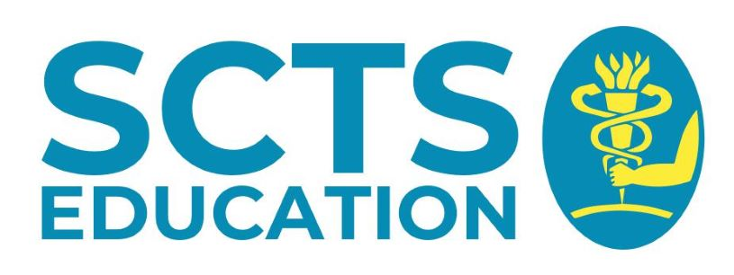
SCTS Education Operative Video Prize 2022
Name

ST level 1 2 3 4 5 6 7 8
For Trust Appointed Doctors, number of years in Cardiothoracic Surgery at registrar level

Current hospital

Video

Patient initials Patient consent obtained: Y N

Date video taken

Name of consultant responsible for the operation

Hospital where video was recorded

File format File resolution

Recording device

Operative procedure

Operative category ST group (3-8) Video number (1-10)

- I would like to submit the enclosed video for consideration for the SCTS Education Operative Video prize.

- I confirm that the video has been taken with the patient’s consent, complies with the local Trust policy on taking videos in the operating room and that it does not breach patient confidentiality.

- I also consent to SCTS Education using the video for educational or teaching purposes.

- I confirm that I am a member of the SCTS

Signature Date

Consultant signature Date

To submit your operative video, please send a Dropbox of WeTransfer link with the enclosed submission form to education@scts.org.

Closing date Friday 7th January 2022.

