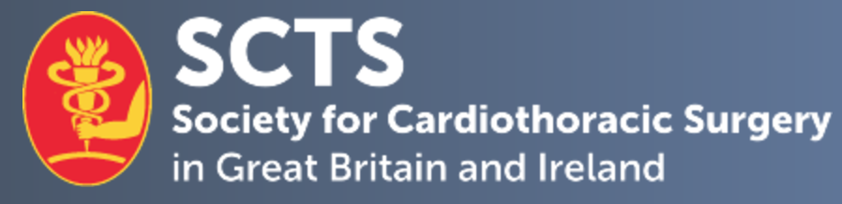

SCTS NAHP Associate Meetings Secretary Application Form

Personal details.

Candidate Name
Current post & hospital
Mobile number: |  | E-mail Address:
Current SCTS member | Yes No

- 1. Describe your previous contributions to the specialty of cardiothoracic surgery and to the Society for Cardiothoracic Surgery (SCTS).
No more than 300 words

- 2. Describe your previous involvement in organising meetings or educational events.
No more than 300 words

- 3. If appointed, describe your proposed plans and vision for the future.
No more than 300 words

- 4. Provide any further information to support your application.
No more than 300 words

Declaration:
I hereby confirm that the details above are correct and, if elected as SCTS NAHP Associate Meeting Secretary, to attend meetings on a regular basis.

Applicant signature:

Date:

Proposing member signature:

Proposing member:

Please complete and return this form, as well as a brief CV, by email to nadia@scts.org.

Closing Date for applications: 5pm, Friday 16th February 2026

