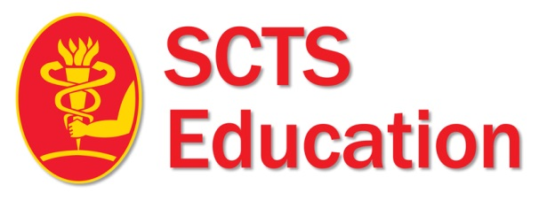

Special Ionescu Fellowships

celebrating 50 years of the Pericardial valve

Application Form
Ionescu NTN Trainee Travelling Fellowship: 1 award, £10,000

Eligible applicants include nationally-appointed cardiothoracic surgical trainees in Great Britain & Ireland, who have not yet secured a consultant post. The fellowship is awarded to support a visit to a cardiothoracic surgery centre, which may be in the UK, Ireland or elsewhere in the world. It is designed to enhance the experience of the applicant in preparation for a career as a Consultant Cardiothoracic Surgeon.

Deadline 15th August 2020.

Applications will be judges on:
- Clinical experience (including log book)
- Evidence of engagement with SCTS
- Publication
- Research
- Evidence of Leadership
- Relevant skills pertaining to the fellowship. Please include an up to date summary CV.
(Please do not hyperlink publications to google scholar/ pubmed / research gate).

Have you previously applied for this fellowship | Yes | No
If yes, when and what was the outcome

Candidate Name
Current post & hospital
E-mail Address:
Mobile Number:

Are you a current SCTS Member?  Please note applicants must be a member of the SCTS to be eligible for these fellowships. To apply for membership please go to https://membership.scts.org/Join-Online | Yes | No

Fellowship post details
Hospital
Supervising Consultant / Professional
What is the salary attached to the post (if applicable)
Start date & duration of fellowship

1. Describe your current skills, experience and competencies relevant to the fellowship
2. Describe what are your objectives for this fellowship
3. Describe the beneficial effects of the fellowship to the NHS
4. Please provide any further information to support your application

Projected Expense Form

Please complete the form to project the expenses regarding the fellowship.

Name:

Email Address:
Fellowship sites:
Fellowship duration:
No of delegates/ team
Dates
Relocation costs (where applicable)
Air fares (Economy only)
British Rail (Advance Second Class is acceptable)

Car mileage @ 40p per mile
Taxis

Tube
Parking
Accommodation
Any scientific meeting registration
Other (specify)

TOTAL

Please save your expense receipts to include in your fellowship report.

Please save the following documentation below as ONE PDF document and send to Letty Mitchell fellowships@scts.org

- Completed application form

Curriculum vitae (maximum 2 pages)

Letter from the visiting centre

Letter of acceptance from consultant cardiothoracic surgeon with details of the experience to be gained.

Letter of support from their Training Programme Director.

Tick
I have attached a recent high resolution picture for SCTS Website publication if awarded the fellowship.
I agree to inform SCTS education committee of any changes to the fellowship plan in a timely manner.
I agree to continue to be a member of SCTS for two years after completion of the fellowship.
I agree to provide a written report about the fellowship which will be published in the SCTS Website and social media and if selected in the printed bulletin.
I agree to provide a 5 minute video summarizing the fellowship which will be broadcast in the SCTS AGM and website and circulated in SCTS social media.
I will return any unused funds to SCTS Education on completion of reports and submission of expenses.
I will respond to SCTS in a timely manner if future feedback is sought about the fellowship.
I agree to be a contact point to future awardees in relation to my fellowship plan.

I confirm that the details above are correct:

Name (applicant):

Signature:
Date:

The fellowship monies are paid via bank transfer. Any queries contact fellowships@scts.org

