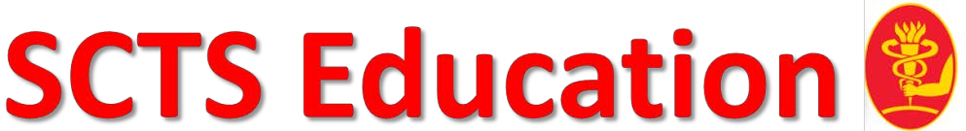

SCTS-Ionescu 90 Fellowships

Application Form 2020
SCTS-Ionescu 90 Consultant Team Fellowships:
3 awards, £15,000 each

Eligible applicants include all members of the multi professional team which should include a Consultant Cardiothoracic Surgeon currently working in Great Britain & Ireland in all sub-specialties, including adult cardiac surgery, thoracic surgery, congenital cardiac surgery and transplantation surgery. The fellowship is awarded to support a visit of a team to a cardiothoracic surgery centre, which may be in the UK, Ireland or elsewhere in the world.

Deadline 15th January 2020.

Applications will be judges on:
- Clinical experience (including log book)
- Evidence of engagement with SCTS
- Publication
- Research
- Evidence of Leadership
- Relevant skills pertaining to the fellowship. Please include an up to date summary CV.
(Please do not hyperlink publications to google scholar/ pubmed / research gate).

Have you previously applied for this fellowship | Yes | No
If yes, when and what was the outcome

Candidate Name
Current post & hospital
E-mail Address:
Mobile Number:
Are you a current SCTS Member? | Yes | No

Fellowship post details
Hospital
Supervising Consultant / Professional
What is the salary attached to the post (if applicable)
Start date & duration of fellowship

1. Describe your current skills, experience and competencies relevant to the fellowship
2. Describe what are your objectives for this fellowship
3. Describe the beneficial effects of the fellowship to the NHS
4. Please provide any further information to support your application

Projected Expense Form

Please complete the form to project the expenses regarding the fellowship.

Name:

Email Address:
Fellowship sites:
Fellowship duration:
No of delegates/ team
Dates
Relocation costs (where applicable)
Air fares (Economy only)
British Rail (Advance Second Class is acceptable)

Car mileage @ 40p per mile
Taxis

Tube
Parking
Accommodation
Any scientific meeting registration
Other (specify)

TOTAL

Please save your expenses receipts to include in your fellowship report.

Applicant and Surgeon in the team must be a member of the SCTS to be eligible for these

fellowships.

The Applicant must accompany the visiting team

- Completed application form (one per team)

Curriculum vitae (maximum 2 pages)

Letter from the visiting centre

Letter of acceptance from consultant cardiothoracic surgeon with details of the experience to be gained.

Letter of support from Clinical Director or Medical Director.

Please save your completed application along with accompanying documentation as one PDF document and send to Letty Mitchell fellowships@scts.org

I confirm that the details above are correct:

NAME (APPLICANT):
SIGNATURE:

DATE:

The fellowship monies are paid via bank transfer. Any queries contact fellowships@scts.org

